Prayer activities, crafts and games

Prayer Activities
The following prayer activities are given as suggestions for use with younger children (or those who prefer to be active) during the All-age Service – or in Sunday School/Kids’ Church following the BSG21 Children’s Talk.
- Praying for my school
You will need: sheets of drawing paper, coloured pencils or crayons.
Encourage children to draw a picture of their school classroom or nursery (even new starts should have had a pre-school visit). What does it look like? Where might they sit? Where is the teacher? Draw some boys and girls they know are in their class.
Invite them to imagine Jesus in the classroom too. Help them to understand that where they go, he goes too, not as a person like you or me, but as God’s Holy Spirit. This means he is always with us, even as we go back to school, and that we are going back to school with God! How does that make the children feel?
Pray in turn: “Jesus, help me remember I am going back to school with you.”
- Praying for one another
You will need: a net, hung on a wall in the room you meet; pegs; printed copies of BSG21 Fish Template.
Ask the children to cut out a fish shape and write their name clearly in large writing on one side. Chat about the story as they do this.
Once they have done this, give them a peg and ask them to peg their fish on the net.
Help them to consider all the fish hanging on the net – how many boys and girls are just like them, returning to school this week – not just where you live, but all over the country. Remind the children that God made the fish, and God made them. He knows what they need, and he takes care of them in the same way he took care of the disciples in the story.
Invite the children to find a partner or a friend.
  - If the children are used to praying aloud, invite them to share with one another their feelings about going back to school. They can then pray for one another.
  - If the children are not used to praying aloud, say you are going to pray: “Lord, show your love to (name) as they put their hope in you.” When they hear you pause after “show your love to…”, they should say the name of their partner. After the children speak out names, finish the prayer by saying “… as they put their hope in you. Amen.” At the end, encourage the children to unpeg their friend’s fish to take home as a reminder to pray for them this coming week.
The following prayer activity is designed to encourage family prayer, and can be made either at church or at home.
Family Fish Prayers
You will need: 2 sheets of paper; sticky tape; scissors; BSG21 Family Fish Prayers (print one for each child).
- Take a sheet of paper. Cut out a long strip and a large triangle.
- Fold the long strip in two. Tape or glue the triangle to the long strip. This makes the sail.
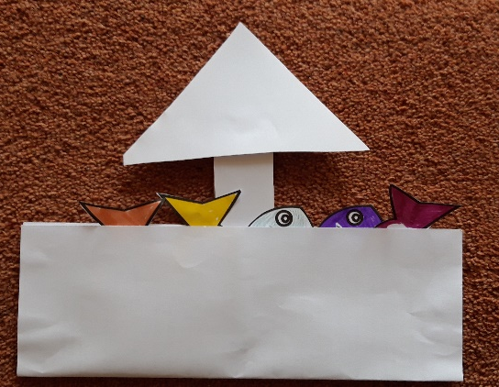
- Take one sheet of paper and fold it lengthwise to make the boat.
- Stick or tape the sail halfway along the back inside fold, then glue or stick the sides to complete the boat.
- Cut out the Family Fish Prayers and colour them. Be careful not to colour over the words!
- Place the Fish Prayers inside the boat. Each fish shape has a different prayer on it:
  - When I feel worried because my work is hard, Jesus help me remember you are with me.
  - When I want to tell my friends about you, Jesus help me remember you are with me.
  - When I feel lonely in the playground, Jesus help me remember you are with me.
  - When I am happy and excited, Jesus help me remember you are with me.
  - When I know I need to make a hard choice, Jesus help me remember you are with me.
  - When I am having a really bad day, Jesus help me remember you are with me.
Pull out a fish prayer at breakfast every morning, or in the car on the way to school, or at bedtime the night before and pray it together as a family.

Crafts and Games
For pre-schoolers
There are plentiful ideas for crafts and downloadable colouring sheets available on Pinterest. The following game, a storytelling option and song ideas can be found at Childrensministry.com.
- Jesus catches fish game
You will need: a net.
To set up the story and have fun together, play a short game. Use a net as an illustration to talk about fishing. Have you ever seen someone catch a fish?
Tell the children they can pretend to be fish and ‘swim’ across the room. As they do this you and another leader will ‘throw the net’ and if they are caught, they must flop down on the floor. Do this several times for fun and then direct children who are caught to go and sit in the ‘story area’.
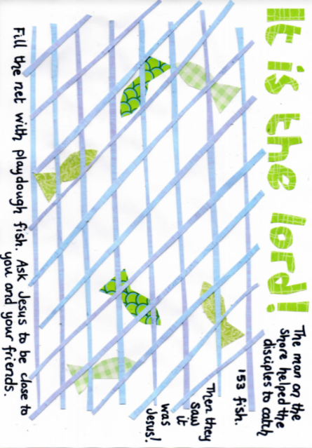
- Jesus on the beach playdough mat and prayer (this craft can be found at Flamecreativekids.blogspot.)
You will need: a laminator; printed copies of the pdf Playdough Mat and playdough for each child.
Laminate a playdough mat for each child. Invite the children to make fish from playdough and add them to the ‘net’ on their mat.
As they do this, either tell the story of John 21, or chat about it if they have already heard the story told.
Jesus wanted to spend time with his friends. He enjoyed their company. He wants to be our friend too. Jesus was with the fishermen as they went fishing. Jesus is with us as we go to nursery too. Not as a person, like you and me, but as God’s Spirit. This means we can’t see him with our eyes, but he is always there with us.
Encourage the children to pray, asking Jesus to be close to them and their friends in nursery this coming week; or say a prayer, mentioning each child by name as you pray.

For primary aged children
Sermons4kids.com has a range of resources available for this age group. These include:
- Group Activities (various fish-related games)
- Colouring Page
- Crossword
- Decoder
- Dot to Dot
- Missing letters
- Word Search
- Worship Bulletin – this is a double-sided download containing four different activities which would be ideal to provide for children during the all-age service, particularly those who find sitting still and concentrating very difficult.
Craft Idea (this idea is from Pinterest)
You will need: fun foam or strong card; a fish template; sticky dots or stickers; marshmallows; Smarties; melted chocolate (or googly eyes); paper; stapler; colouring pens.
Draw and cut out fish shapes using coloured card or fun foam.
Give one to each child to decorate using whatever is available, eg foam shapes, sticky dots, stickers. Use marshmallows and Smarties* stuck on with melted chocolate for eyes (see picture) or use googly eyes instead. Invite the children to write the memory verse on either the front or the back of the fish. *If you are using food, please be aware of any allergy needs within your group.
Lord, show your love to us as we put our hope in you. Psalm 33
If using a non-edible eye, you could also make the fish into the front cover of a drawing/notepad by cutting out blank sheets of paper of the same shape and stapling them behind the cardboard fish at its ‘tail’. See picture below.
