Bible Story Script
Note: The slide numbers below indicate where they fit within the slide set that accompanies the all-age service: BSG21 All-Age Service PPT Slides.

John 21:1-14
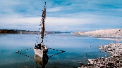
Slide 3 Later, Jesus showed himself to his followers by Lake Galilee. This is how it happened. Some of the followers were together. They were Simon Peter, Thomas (called Didymus), Nathanael from Cana in Galilee, the two sons of Zebedee, and two other followers.

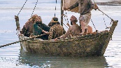
Slide 4 Simon Peter said, “I am going out to fish.” The other followers said, “We will go with you.” So they went out and got into the boat. They fished that night but caught nothing.

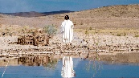
Slide 5 Early the next morning Jesus stood on the shore. But the followers did not know that it was Jesus. Then he said to them, “Friends, have you caught any fish?”

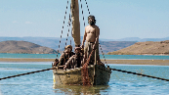
Slide 6 They answered, “No.” He said, “Throw your net into the water on the right side of the boat, and you will find some.”

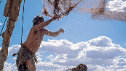
Slide 7 So they did this.

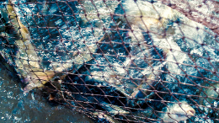
Slide 8 They caught so many fish that they could not pull the net back into the boat.

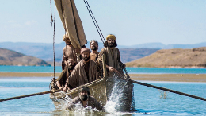
Slide 9 The follower whom Jesus loved said to Peter, “It is the Lord!” When Peter heard him say this, he wrapped his coat around himself. Then jumped into the water.

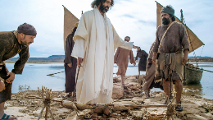
Slide 10 The other followers went to shore in the boat, dragging the net full of fish. They were not very far from the shore, only about 100 yards. When the followers stepped out of the boat and onto the shore, they saw a fire of hot coals. There were fish on the fire, and there was bread.
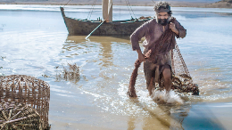
Slide 11 Then Jesus said, “Bring some of the fish you have caught.” Simon Peter went into the boat and pulled the net to the shore.

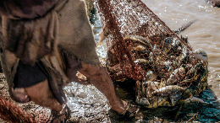
Slide 12 It was full of big fish. There were 153. Even though there were so many, the net did not tear.

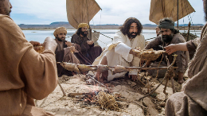
Slide 13 Jesus said to them, “Come and eat.” None of the followers dared ask him, “Who are you?” They knew it was the Lord. Jesus came and took the bread and gave it to them. He also gave them the fish. This was now the third time Jesus showed himself to his followers after he was raised from death.

Scripture taken from the International Children's Bible®. Copyright © 1986, 1988, 1999 by Thomas Nelson. Used by permission. All rights reserved.
Images courtesy of FreeBibleImages.com

