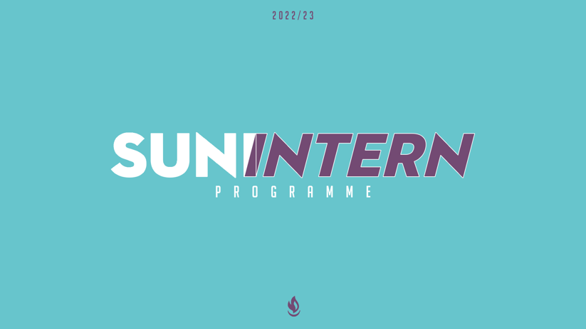

Application for SUNI Internship 2022/23

Applications must be completed and returned to Joanne Coulter by 12 noon on Tuesday 3rd May, 2022.
Please complete in black ink. CVs, additional information or additional pages will not be considered.
The Media position will be based in Belfast. The Schools internships will be based out of the area office shown in brackets beside each area listed below. Please note that the majority of the first month of all SUNI Internships will be based in Belfast due to induction and training.

Internship Positions Available  (Choose one or more from those listed below) | Please number which Internship position you are applying for (You can apply for more than one but please show preference by numbering 1,2,3 etc - 1 being first preference).
Schools
Antrim and Lisburn (Lisburn)
Ballymena (Ballymena)
East Antrim (Carrickfergus)
East Belfast (Belfast)
Fermanagh & Fivemiletown (Enniskillen)
North Belfast & Newtownabbey (North Belfast)
North Coast (Coleraine)
North Down and Newtownards (Bangor)
North West (Derry/Londonderry)
Omagh & Castlederg (Omagh)
Special Educational Needs (Belfast)
Media (Belfast)

CONFIDENTIAL
TITLE
SURNAME
FORENAME(S)
ADDRESS
POSTCODE
TELEPHONE
MOBILE
EMAIL
DATE OF BIRTH

PERSONAL DETAILS

Church Name
(including denomination/fellowship)
Church Leader’s Name
Contact details
Daytime Telephone
Email

Church Affiliation

SCHOOLS ATTENDED AND QUALIFICATIONS GAINED
SCHOOLS | QUALIFICATIONS

UNIVERSITY/COLLEGE ATTENDED AND QUALIFICATIONS GAINED
UNIVERSITIES/COLLEGES | QUALIFICATIONS

EMPLOYMENT HISTORY, INCLUDING PART-TIME POSITIONS
EMPLOYER | POST | DATES EMPLOYED | DUTIES | REASON FOR LEAVING

TRANSPORT

PLEASE NOTE THE SUNI INTERNSHIP REQUIRES YOU TO BE ABLE TO PROVIDE YOUR OWN TRANSPORT (BY MEANS OF PUBLIC TRANSPORT OR ACCESS TO A CAR).
If you hold a full UK driving license, please provide the date you passed your test:
____ / ____ / ____

YOUR STORY

OUTLINE HOW YOU CAME TO FAITH IN JESUS AND WHAT IMPACT THIS HAS ON YOUR EVERYDAY LIFE

OUTLINE YOUR CURRENT INVOLVEMENT IN YOUR LOCAL CHURCH

YOUR EXPERIENCES

EXPLAIN WHY YOU ARE APPLYING FOR THIS INTERNSHIP, INCLUDING WHY YOU THINK YOU ARE SUITABLE FOR IT AND WHAT RELEVANT EXPERIENCE YOU HAVE FOR THE ROLE

ANY OTHER INFORMATION WE SHOULD KNOW?

REFERENCES
Please give the names and contact details for two people to act as referees for you. These should be people who know you well but not members of your family, SU Council members or current members of staff. If possible, they should be from two different settings e.g. church and work/education.
Name
Address
Daytime phone
email

Please note since the position involves contact with children, Scripture Union will as part of its Child Protection Policy undertake confidential investigation of the applicant through the means of an enhanced disclosure check with Access N.I. and Barred Working with Children List. Please note that having a criminal record will not necessarily debar you from working with Scripture Union. Those who take up an intern position will also need to sign up to our Ethos Statement. If you are invited to an interview, a copy will be available for you to read on the day.
Please note that interviews will take place on Monday 9th May 2022. Media Intern applications can be interviewed at an earlier date if necessary. Successful applicants will start on Thursday 1st September.

I declare that all the information given on this form is correct and not intended in any way to mislead those assessing my application. I have read and am in full personal agreement with the Aims, Beliefs and Working Principles of Scripture Union.
Signed _____________________________________ Date ___________________

